

**Green University of Bangladesh**

**Department of Computer Science and Engineering (CSE)**

**Faculty of Sciences and Engineering**

**Semester: (Fall, Year: 2024), B.Sc. in CSE (Day)**

**Lab Report NO #02**

**Course Title: OOP Lab**

**Course Code: CSE 202**

**Section: D9**

**Lab Experiment Name:**  Class, Objects, Object Arrays, Constructors, Methods

**Student Details**

|  |  |  |
| --- | --- | --- |
| **Name** | | **ID** |
| **1.** | Rukonuzzaman Topu | 232002280 |

**Lab Date : 29/09/24**

**Submission Date : 06/10/24**

**Course Teacher’s Name : Wahia Tasnim**

**[For Teachers use only: Don’t write anything inside this box]**

|  |
| --- |
| **Lab Report Status**  **Marks: ………………………………… Signature: .....................**  **Comments: .............................................. Date: ..............................** |

**1. INTRODUCTION**

The purpose of this lab reports is to know the concepts of Class, Objects, Object Arrays, Constructors and Methods in java program. Here, we will see how to calculate area of triangle, rectangle and circle. In this lab report our aim is to solve some real-world problems efficiently.

**2. OBJECTIVES**

The primary objectives of this lab report are as follows:

• To gather knowledge of Class, Objects, Object Arrays, Constructors, Methods.

• To implement the constructor, array and methods.

**3. IMPLEMENTATION**

Task 1: Take three constructors where constructors will calculate the area of triangle, area of rectangle and area of circle using overloading constructor.(Use Switch Case)

Solution:

import java.util.Scanner;

class areaCalculation {

    double area;

    areaCalculation(double base, double height) {

        area = 0.5 * base * height;

        System.out.println("Area of Triangle: " + area);

    }

    areaCalculation(double length, double breadth, boolean isRectangle) {

        area = length * breadth;

        System.out.println("Area of Rectangle: " + area);

    }

    areaCalculation(double radius) {

        area = Math.PI * radius * radius;

        System.out.println("Area of Circle: " + area);

    }

    public static void main(String[] args) {

        Scanner s = new Scanner(System.in);

        System.out.println("Select shape to calculate area: ");

        System.out.println("1. Triangle \n2. Rectangle\n3. Circle");

        int choice = s.nextInt();

        switch (choice) {

            case 1:

                System.out.print("Base: ");

                double base = s.nextDouble();

                System.out.print("Height: ");

                double height = s.nextDouble();

                new areaCalculation(base, height);

                break;

            case 2:

                System.out.print("Length: ");

                double length = s.nextDouble();

                System.out.print("Breadth: ");

                double breadth = s.nextDouble();

                new areaCalculation(length, breadth);

                break;

            case 3:

                System.out.print("Radius: ");

                double radius = s.nextDouble();

                new areaCalculation(radius);

                break;

            default:

                System.out.println("Invalid choice");

                break;

        }

        s.close();

    }

}

Outputs:

**1.**

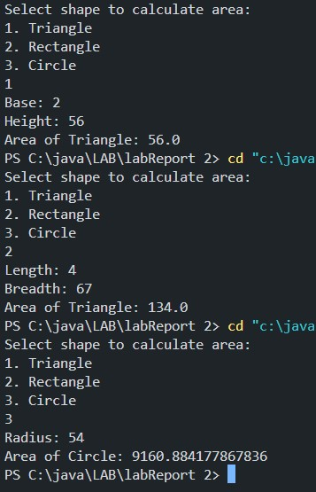

**4. DISCUSSION**

The task involves computing the areas of a triangle, rectangle, and circle by utilizing constructor overloading in Java. By creating multiple constructors with varying parameters, shape-specific area calculations can be performed. A switch-case statement is employed to select the appropriate formula based on user input. This approach effectively showcases the use of constructor overloading along with conditional logic, ensuring a clean and organized solution.